FEE BENCHMARKING INSTRUCTIONS
Business Advisor requests benchmark for plan by emailing Sales Support and includes Current Fee Schedule and most recent Quarterly Invoice and completed RPAG Fee Benchmark Request Form.
Completing RPAG Fee Benchmark Request Form:
- Open form and select tab 2 “Annualization Calculation”.
- Key in quarterly fees in “Quarterly Charge In $$” column from most recent quarterly invoice. These quarterly charges are automatically annualized and carried to Tab 1 “Annualized Fees”.
- Select Tab 1 and enter the plan name and report date at the top left of the first page. (Report date should match the “Market Value Date” listed on the invoice used to populate tab 2. )
ENVESTNET SECTION
Log into Envestnet and locate the desired plan. You will gather Plan Balance and Gross Investment Expense Ratio from Envestnet.
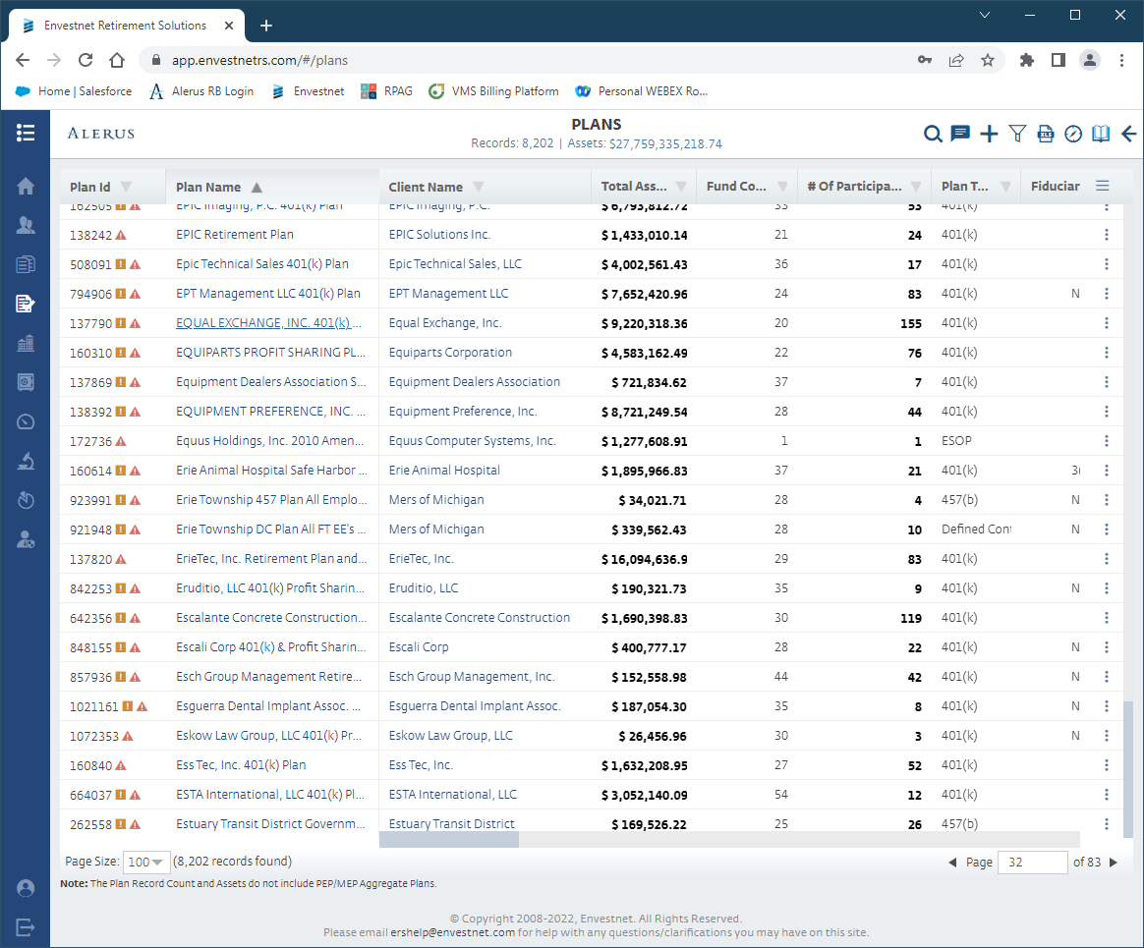
- Once plan being benchmarked is open use balance on “Plan Summary” page from Envestnet entering this amount in the “Total Assets” cell on tab 1 of the request spreadsheet. This date should coincide with the “Market Value Date” on the invoice being used for calculation. (If this date is more recent that the Market Valuation Date on the invoice (Envestnet is updated monthly) you can take balance directly from the Envestnet Quarterly Monitoring Report.
- The Plan Balance can also be found by logging into alerusrb.com and accessing the Plan Balance screen. Be sure to enter the “View Balances by Investment As of Date” so that it matches the Invoice Market Valuation Date.
- 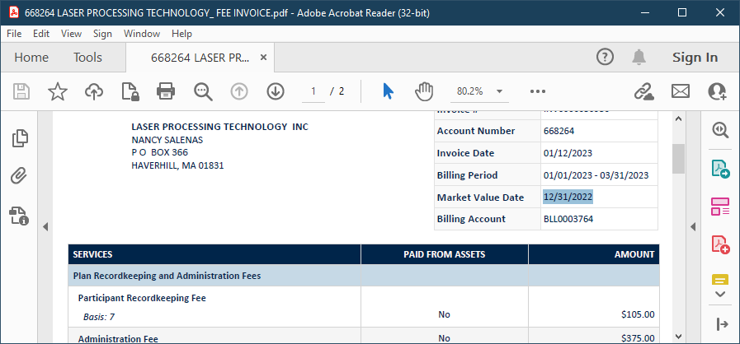

- Next, to access Average Weighted Gross Investment Expense scroll down to “Investments” and select the “Chart” icon on right next to XLS icon and Pencil. (Hover over chart and you will see it is labeled “Plan Monitoring”.

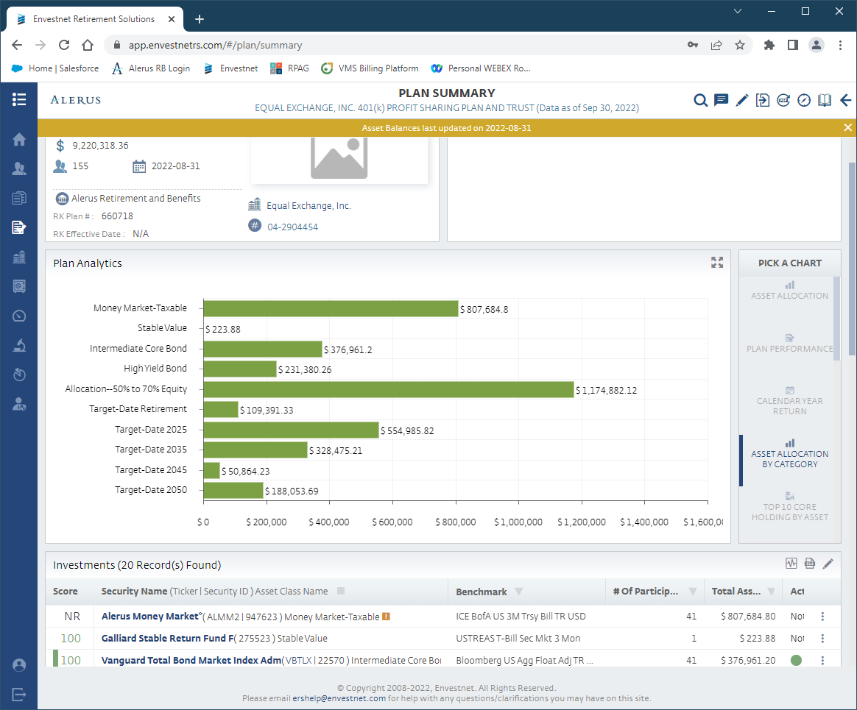

“Plan Fees” From top menu bar.
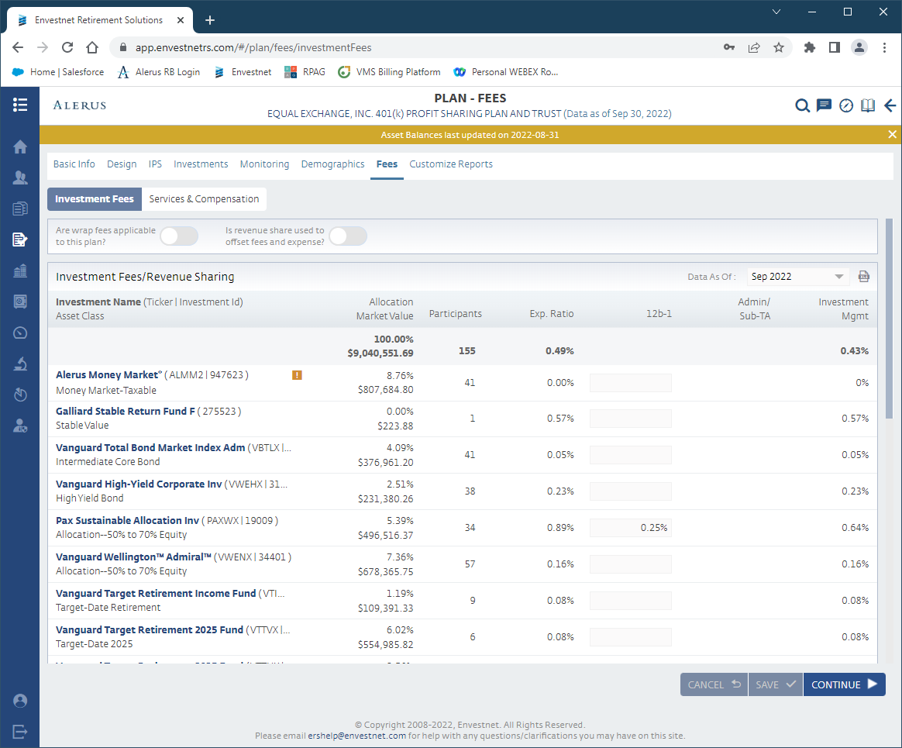

- Locate Exp. Ratio and enter it in Fund Expense cell on Tab 1 of Request Form. (Enter the rate not dollars.)
Close Envestnet
FEE SCHEDULE SECTION
Open the plan’s fee schedule and note on Tab 1 of Request Form whether the plan is Fee Equalization or Fee Offset at the bottom of the Summary page (1st Tab) of the Benchmarking Fee Structure excel sheet. If the Plan is fee offset, be sure to make note as to whether the offset is for the employer first or Participants first in the “Notes” section. If revenue sharing is included on invoice you should also list it in “Notes” section for further discussion if necessary.
Close the fee schedule
Review:

- Check to ensure the quarterly fee total on invoice matches quarterly fee total on Tab 2 of Request Form. See examples below:
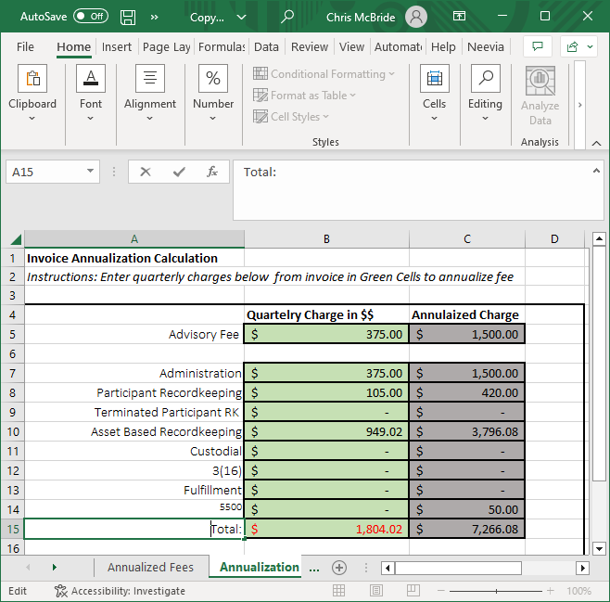
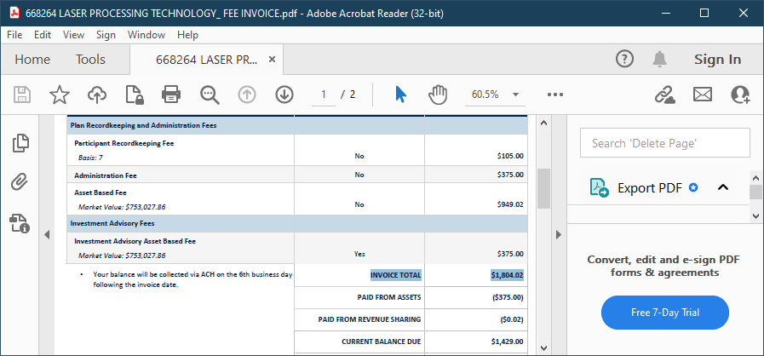

- Return to tab 1 of “Fee Benchmark Request Form
- Add any additional notes you may wish to cover with the client relevant to plan fees such as handling of revenue, use of forfeitures to offset fees, etc.
- Enter total employees with balances from Invoice in Tab 1 of request form. (Combine Actives with Terminated Participants billed on invoice).
- Save Request From and email it to Sales Support at: salessupport@alerus.com
- Time Frame to receive completed benchmark reports is 3 business days for request received in good order.

